**7.WiringPi library**

**1. Introduction of wiringPi**

The wiringPi is a GPIO control library function for the Raspberry Pi platform. The wiringPi library contains a wealth of library functions such as GPIO library, I2C library, SPI library, UART library and software PWM library,etc.

**2.Version information of wiringPi**

You need to input: gpio -v . As shown in the figure below.

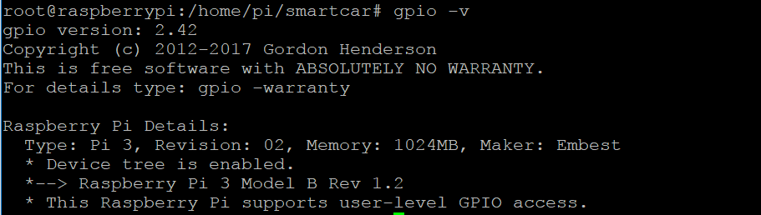

1. **Use of GPIO**

You can input : gpio readall to get the correspondence between the wiringPi and the GPIO interface of the Raspberry Pi, as shown in the following figure:

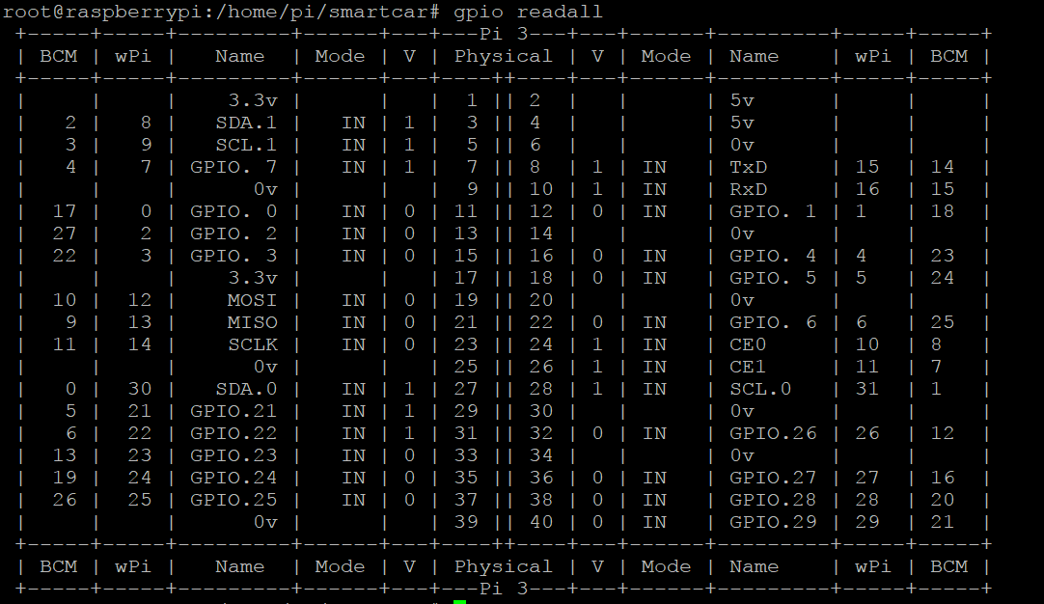

The Physical column is the pin definition of the physical interface J8 of the Raspberry Pi.

The wPi column is the corresponding value of the GPIO in the wiringPi library.

The BCM column is the corresponding value of the GPIO in the BCM2835 C library.

(Note:we use the wiringPi library function in the development of the Raspberry Pi wifi smart robot car.)